Gizmo’s Pawesome Guide to Mental Health: Early ChiLdhooD Introduction
Templates

Letter Template to Parents/Caregivers
<<Insert Date>>
Dear Parent/Guardian:

We are pleased to share with you that <<___school/site/program and/or ___class/group>> has obtained the Gizmo’s Pawesome Guide to Mental Health© Early Childhood Introduction to be implemented in our <<school/site/grades/program>>.
Gizmo’s Pawesome Guide to Mental Health was developed to introduce mental health and wellness knowledge and skills to school-aged youth with the hope that they may keep and apply what they learn for a lifetime to help them stay healthy and safe. This early childhood adaptation of the original Gizmo curriculum aims to help young children understand their emotions, learn activities they can use to support their own well-being, and how to identify and talk with trusted adults if they are struggling. The intended knowledge and skills gain includes:
- Knowledge of basic emotions and how to identify them;
- Daily activities that support mental wellness;
- How to identify and connect with trusted adults; and
- Resources to share with trusted adults.

The activities strive to help young children, their trusted adults, and the settings in which they live support their mental health and create a greater sense of individual and community connectedness.

We look forward to introducing you and your child to this wonderful new resource and encourage you to connect with us if you have any questions. Please contact - _____<<name; email; phone>>_. You may visit https://www.gizmo4mentalhealth.org/ to view the Guide, get information about the curriculum, and find resources for adults and children’s mental health.

Sincerely,
__________<<Your name >>

Me and My Trusted Adults
My trusted adults care about me, make me feel safe, listen to me, spend time with me, and help me.
Write your name or paste a picture of you in the big circle. Write the names, draw, or paste pictures of your trusted adults around the outside of the circle. You can add people at any time as more trusted adults become part of your life

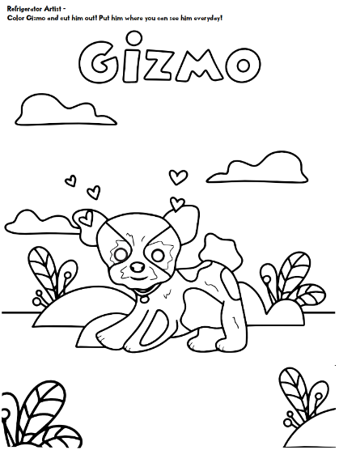
Gizmo Goes Home!

Gizmo knows when he’s having trouble with his feelings it can help to spend time doing something with other people. Are there special things that your family likes to do together? Talk with your grownups to think about special things that you like to do together and come back and share with the class on Monday!

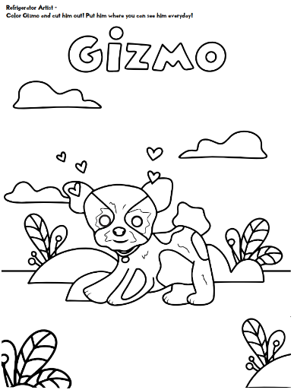
Gizmo Goes Home!

Gizmo knows when he’s having trouble with his feelings it can help to spend time doing something with other people. Are there special things that your family likes to do together? Talk with your grownups to think about special things that you like to do together and come back and share with the class on Monday!
Gizmo Goes Home!

Gizmo knows when he’s having trouble with his feelings it can help to spend time doing something with other people. Are there special things that your family likes to do together? Talk with your grownups to think about special things that you like to do together and come back and share with the class on Monday!
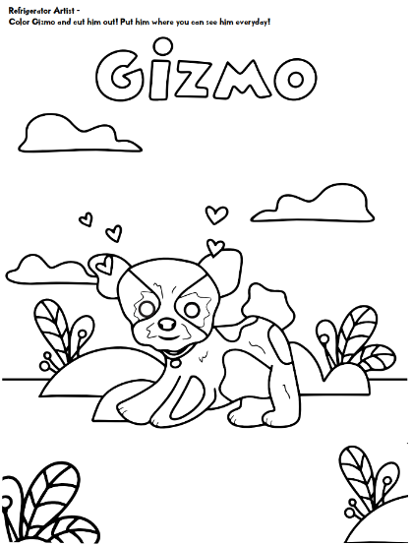
Gizmo Goes Home!

Gizmo knows when he’s having trouble with his feelings it can help to spend time doing something with other people. Are there special things that your family likes to do together? Talk with your grownups to think about special things that you like to do together and come back and share with the class on Monday!
Gizmo Goes Home!

Taking a walk with his grownups and noticing 3 pretty or interesting things on his walk helps Gizmo feel calm. Take a walk with your grownups, talk about what is pretty or interesting on your walk, and come back and share with the class on Monday!

Gizmo Goes Home!

Taking a walk with his grownups and noticing 3 pretty or interesting things on his walk helps Gizmo feel calm. Take a walk with your grownups, talk about what is pretty or interesting on your walk, and come back and share with the class on Monday!

Gizmo Goes Home!

Taking a walk with his grownups and noticing 3 pretty or interesting things on his walk helps Gizmo feel calm. Take a walk with your grownups, talk about what is pretty or interesting on your walk, and come back and share with the class on Monday!

Gizmo Goes Home!

Taking a walk with his grownups and noticing 3 pretty or interesting things on his walk helps Gizmo feel calm. Take a walk with your grownups, talk about what is pretty or interesting on your walk, and come back and share with the class on Monday!

