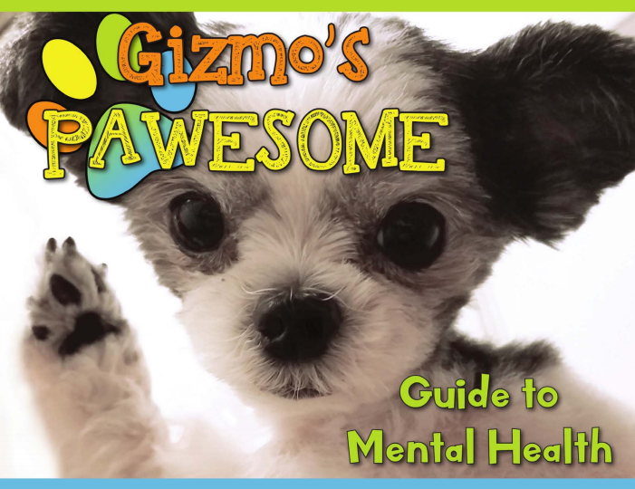

* **About:** Gizmo’s Pawesome Guide to Mental Health© takes an an upstream approach to support the mental health and wellness of youth through Gizmo’s friendly messaging by:

1. Introducing the concept of mental health;
2. Sharing how one may care for their own mental health daily;
3. Identifying when one’s mental health needs attention and how to use healthy coping strategies;
4. Defining trusted adults and how to connect with them; and
5. Making a personalized mental health plan that can be used daily.

The Guide also includes fun activities, and resources trusted adults can use to help the youth in their lives.

* **To request a Gizmo’s Pawesome Guide to Mental Health© Read Along, please contact:**

Enter a name, contact email and/or phone number here

For more information on Gizmo’s Pawesome Guide to Mental Health©, Pledge for Mental Health, Elementary Curriculum, Read Alongs, and Fun Activities visit: [www.gizmo4mentalhealth.org](http://www.gizmo4mentalhealth.org)

[Insert your logo]