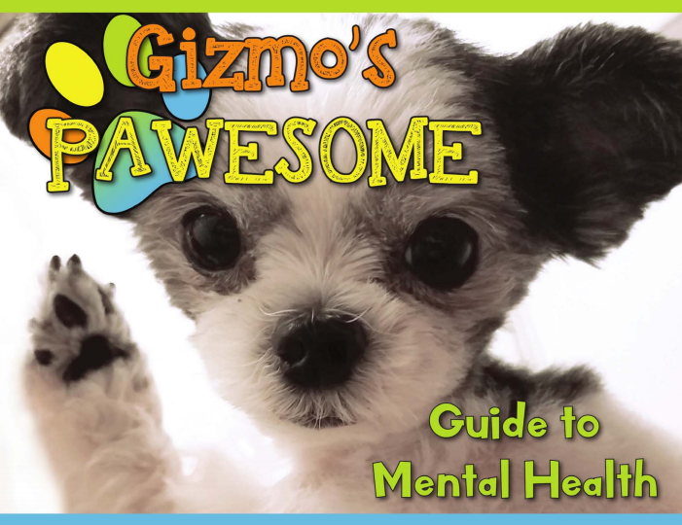

- About: Gizmo’s Pawsome Guide to Mental Health© takes an an upstream approach to support the mental health and wellness of youth through Gizmo’s friendly messaging by:
- Introducing the concept of mental health;
- Sharing how one may care for their own mental health daily;
- Identifying when one’s mental health needs attention and how to use healthy coping strategies;
- Defining trusted adults and how to connect with them; and
- Making a personalized mental health plan that can be used daily.

The Guide also includes fun activities, and resources trusted adults can use to help the youth in their lives.

- Read-Along Host: Enter Chapter name (e.g. AFSP CT Chapter)
- When: Enter date and time (e.g. Thursday, February 18, 2021)
- For: Enter who you are hosting the Read-Along for (e.g. Youth ages 5-11 and their Trusted Adults)
- Register today at: Enter the registration link
- For more information please contact: Enter a contact email and/or phone number

For more information on Gizmo’s Pawsome Guide to Mental Health©, Pledge for Mental Health, Elementary Curriculum, Read Alongs, and Fun Activities visit: www.gizmo4mentalhealth.org

